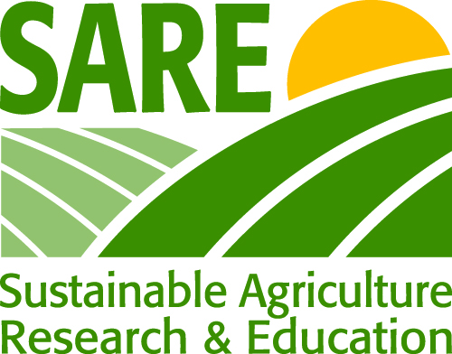
United States Department of Agriculture—SARE

Begun in 1988, the Sustainable Agriculture Research &
Education (SARE) program is a national initiative funded by USDA-NIFA to advance sustainable farming systems through research, education and extension.

Visit SARE on the web at www.sare.org
Image/Video/Figure Release and Authorization Form

Image/video/figure name(s) (including file name):
- ______________________________________________________________
- ______________________________________________________________
- ______________________________________________________________

Description of (circle one) image(s)/video(s)/figure(s): (use back of form or more pages if you need more room)

- ______________________________________________________________

- ______________________________________________________________

- ______________________________________________________________

Release:
I hereby grant the Sustainable Agriculture Research and Education (SARE) program and United States Department of Agriculture (USDA) nonexclusive rights and permissions to use this/these image(s) and/or video(s) and/or figure(s) in their current and all future information products. Uses may include (but are not limited to) the internet, news releases and print publications, per USDA needs. Whenever possible, SARE will provide credit to the content author. If a minor is present in the photo, I obtained the consent of his/her parent or legal guardian (see below).

I agree to these conditions.

Content author’s signature Date

Please print name here

Phone:

Address:

_____ I am ______ am not (select one) a current or past paid staff of SARE or a state PDP coordinator.

For photos depicting minors: I am the parent or legal guardian of _______________________________ (“Minor”) who is under 18 years of age. I hereby consent to him or her being depicted in this photo (if applicable).

________________________________________________________________________________
(parent/guardian signature)

For Project Investigators: If you are submitting this form for a photo uploaded to the SARE projects database, please provide:

Your project number _______________ File name __________________________
And a thumbnail or description of the uploaded photograph.

Send completed forms and questions to communications@sare.org.

