SARE Project Poster Templates: Tips and Instructions
These templates are intended for creating large posters that include important details about the SARE-funded trial, demonstration or research that is the basis for your field day. They were made in PowerPoint. If your field day is unrelated to a SARE grant, please do not use these templates. These instructions provide general guidance on how to add content to the template and how to get it printed. Detailed instructions for using PowerPoint are available online through a quick internet search.

Printing your Poster
- There are numerous options for printing your poster. If you don’t have a favorite local printer, consider options that offer online ordering and delivery, such as FedEx (http://fedex.com/), VistaPrint (http://vistaprint.com/) and Staples (http://staples.com/).
- Options at each printer will vary greatly. You can choose a poster, banner or sign, depending or your needs and mounting requirements. Contact a printer or look on their website to learn about the options.
- All onsite templates are pre-set at the following dimensions:
  - Horizontal: 48” wide by 36” high.
  - Vertical: 36” wide by 48” high.
- FedEx accepts this size for plastic signs and posters; Staples accepts this size for banners (indoor and outdoor vinyl); VistaPrint accepts this size for posters.
- The template can be scaled to a smaller size, but it will need to meet certain aspect ratios based on your printer’s requirements. Contact your printer for advice on how to do this.

Fonts and Colors
- These poster templates have the fonts, colors, and font sizes predefined. We suggest using these recommendations.
- You may resize font in text boxes or headers if it is required to make text fit properly. However, the predefined sizes were chosen based on readability for a poster of this size and purpose. Note that 18pt-20pt font is the minimum size recommended for readability when standing at a two-foot distance.
- Detailed font recommendations are in the margin of the PowerPoint file:
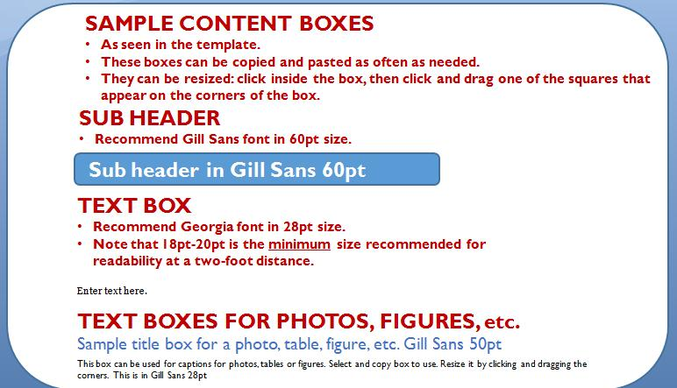
- The color scheme for each region’s template is based on the SARE style guide. Altering colors is not necessary.
Content Boxes
Copying and Duplicating Content Boxes
- Content boxes can be copied and pasted as needed throughout the poster. The content can then be replaced or edited.
  - To select a content box for copying, hover near an edge until you see the four-way arrow, then click on it.
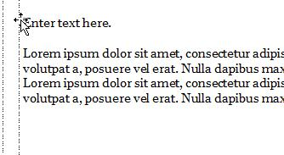
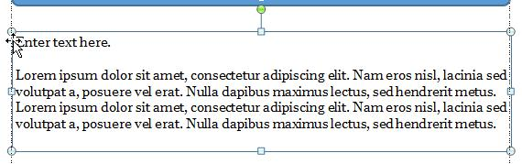
  - Click the Copy button on the top menu (under the Home tab) or CTRL-C (Windows) or CMD-C (Mac.) To paste the new box, use the Paste button or type CTRL-V (Windows) or CMD-V (Mac). The new box will appear over the old box, but offset a little.
  - Click on the new box to select it and drag to desired location.
Resizing Content Boxes
- Click inside the box, then click and drag one of the squares that appear on the corners of the box
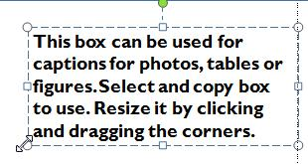
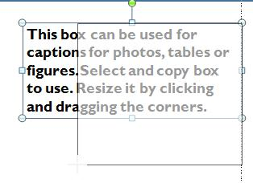
- Release the mouse, click inside box, then type or edit text in the content box.
Using Guides for Aligning Content Boxes and Graphics
- The templates include vertical guides to help you align content (text boxes, images, etc) in columns. Guides are dotted lines that appear on the screen but not in print. As you are moving or resizing a content box and bring it near a guide, its edge will momentarily lock to the guide. Turn guides on/off in the View menu>Guides checkbox.
Content Boxes for Tables and Images
Tables
- A basic sample table is provided in the margin of the PowerPoint file. To add more rows or columns: put the cursor in a row/column next to where you want the new one added, then go to Table Tools>Layout and chose an option (insert above/below/left/right)
- To resize the table: click inside a cell, then click and drag one of the squares that appear on the corners of the table
Images
- Images (photos and graphics) need to meet a certain resolution or image quality requirement in order to print clearly, without being fuzzy or pixelated. This is especially important when printing something large, such as a poster. Resolution requirements may vary by printer (from 150 dpi to 300 dpi), so before inserting images contact your preferred printer to learn about their image resolution requirement and how to see if your photos/graphics are sufficient.
SARE Award Numbers, Logos and Sponsors
If your field day is associated with a SARE-funded project, you must include the USDA logo, SARE logo and award paragraph as they appear in the footer of the sign template.
- In the footer of the sign, please enter your USDA-NIFA grant award number and SARE subaward number (i.e., project number). Your award number and project number are listed in the confirmation letter sent to you when your project was approved. If you have further questions, please contact your SARE regional office.
- Zoom into the paragraph of text in the footer and click the text box to enter award numbers in place of the Xs. 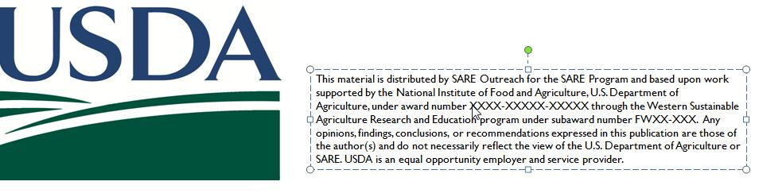
- At the top of the template, enter the SARE subaward number (project number) and Principal Investigator’s name. Click on the sample project number and enter the actual one. Click on the text “Principal Investigator’s Name” and enter the PI’s name.

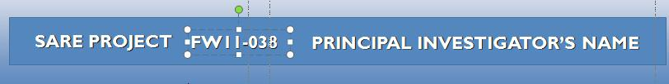
- There is room to add logos of additional field day sponsors.

