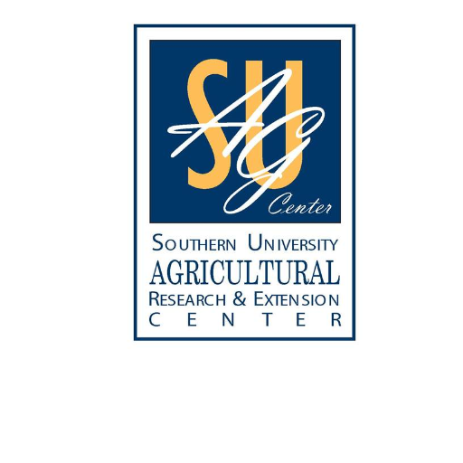
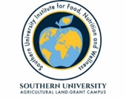

Produce safety alliance Grower (PSA) & Good Agricultural Practices (GAP) TrainingS
When
November 7th 8:00 am-5:00 pm
November 8th 8:30 am-3:00 pm

WHere
Sustainable Agriculture and Rural Development Institute
Southern University Agricultural Research & Extension Center
1209 Diesi Street, Opelousas, LA 70570

Cost
$25 includes lunches, snacks and resource materials

For more information or to register contact:
- Emily King (225) 771-2367 or emily_king@suagcenter.com
- Dr. Fatemeh Malekian (225) 771-0251 or fatemeh_malekian@suagcenter.com
- Chelsea Triche (225) 771-4455 or chelsea_triche@suagcenter.com
*Funding for this publication was made possible, in part, by the Food and Drug Administration through PAR-16-137. The views expressed in written materials or publications and by speakers and moderators do not necessarily reflect the official policies of the Department of Health and Human Services; nor does any mention of trade names, commercial practices, or organization imply endorsement by the United States Government. *

