Research & Education
Call for Proposals (CFP) Packet

Proposal Due Date: Monday, October 26, 2026, 4:00 pm ET

Proposals must be submitted online at: projects.sare.org

Questions?
Visit our website at https://northeastsare.org/ResearchEducationGrant. For questions about this Call for Proposals, contact Heather Omand at: northeast-re@sare.org or 802-656-7654.

All links, templates, and appendices for Large Grant Program Materials,
including registration for live Q&A sessions can be found at: northeast.sare.org/grants/get-a-grant/

About Northeast SARE
The Northeast Sustainable Agriculture Research and Education (SARE) Program offers competitive grants, in sustainable/regenerative agriculture in the Northeast region. We support agriculture in the Northeast that is regenerative so that farmers and farm employees can steward resources to ensure economic viability and a high quality of life.

SARE Legislated Priorities
By law, projects that Northeast SARE funds must contribute to SARE’s legislated priorities:
- Maintain and enhance the quality and productivity of the soil;
- Conserve soil, water, energy, natural resources, and fish and wildlife habitat;
- Maintain and enhance the quality of surface and ground water;
- Protect the health and safety of persons involved in the food and farm system;
- Promote the well-being of animals; and
- Increase employment opportunities in agriculture.

Every proposal must show how it supports one or more of these priorities. Reviewers will use this list when scoring proposals, and projects that don’t align with these priorities may not be funded.

Outcome Statement
All Northeast SARE projects must also explore one or more of the sustainable agriculture themes of the Northeast SARE outcome statement:
Northeast agricultural communities honor the holistic connection among land, water, air, and all living beings. Agriculture in the Northeast is regenerative so all farmers and farm employees can steward resources to ensure sustainability, resilience, economic viability, and a high quality of life.

Administration Priorities
Proposals submitted to this program must be in alignment with current administration priorities (i.e.
Executive Orders—https://www.federalregister.gov/presidential-documents/executive-orders; USDA Research Priorities—https://www.usda.gov/memos). We are unable to fund any proposals where the identity of a particular person and/or community is the key beneficiary. We encourage you to focus on projects that have high farmer impact and can be generally adopted by a high percentage of farmers in the Northeast. We also cannot fund projects focused on climate change but can fund projects that focus on environmental work that provide direct or indirect benefits to farmers. It is encouraged to focus on local agriculture and the significance of regenerative practices to increase production and profitability.

Farmer Impact
Projects having a significant impact/impression on farmers and farming communities is critical. Impact can be economic, social, environmental etc. For example:
- How does the project support farmer/farming community livelihoods?
- How does the project build strong economies through local and/or regional trade?
- How does the project improve crop production?

For impact, replicability is important. Replicability is the ability of another farmer or farming community to obtain similar results when applying the same method(s). In other words, another farmer can utilize the results of the research and/or education to benefit their farming practices or behavior.

Innovation
Innovation is defined as the development or adoption of new concepts or ideas and the successful exploration of new ideas. Ideation is the basis of creativity. The process of creative ideation develops new concepts; Innovation applies them. Creativity can only emerge when an innovator takes the idea and puts it into practice. Innovation can also be social and develop and implement novel and effective solutions to meet social and environmental challenges. The results should improve the welfare and well-being of individual farmers and farming communities and reproducible. Within the scope of Northeast SARE, examples can include, but are not limited to:
- The introduction of a new behavior/practice, one with which farmers are not yet familiar
- The introduction of an improved or better agricultural behavior/practice, which may not be new, but is an improvement upon what occurred before.
- The opening of a new market that has not been entered previously, whether this market has existed previously.
- A new source of supply of materials or goods, again irrespective of whether this source already exists or whether it has first to be created.
- Improved organizational structure and/or capacity.

Statement from USDA, NIFA
Northeast SARE is a program of the USDA, NIFA. The United States Department of Agriculture (USDA), to the extent permitted by law, will no longer make grants or otherwise fund programs or activities that improperly discriminate based on race or sex, including discrimination in the name of Diversity, Equity, and Inclusion policies. Instead, USDA will prioritize merit and efficiency. USDA recognizes programs and initiatives will have the greatest impact when these programs and initiatives put American farmers, ranchers, and foresters first by:
- solving the most pressing challenges they face;
- protecting America’s food, fuel, and fiber supply to enhance national security;
- supporting production of healthy and safe food for consumers;
- expanding and developing domestic markets;
- training the next generation of agriculturalists; and
- fueling innovation to keep American farmers at the forefront of productivity.

The National Institute of Food and Agriculture (NIFA) is committed to advancing these principles and encourages applicants to actively engage farmers, ranchers, and foresters when applying for funding opportunities to ensure relevancy and adherence to them. NIFA also encourages agricultural leaders to engage in the peer review panel process to ensure American producers are better served through research, education, and extension activities.

Projects submitted under this CFP should align with USDA Secretary’s Memorandum 1078- 020 Directive on Departmental Research and Development Priorities:
- Increasing Profitability of Farmers and Ranchers
- Expanding Markets and Creating New Uses of U.S. Agricultural Products
- Protecting the Integrity of American Agriculture from Invasive Species
- Promoting Soil Health to Regenerate Long-Term Productivity of Land
- Improving Human Health through Precision Nutrition and Food Quality

Table of Contents

This proposal packet contains several parts:
- Research & Education Program at a Glance
- Grant Timeline
- Grant Overview & Eligibility
- Proposal Questions and Instructions
- Appendices

PART 1: Research & Education Program at a Glance
Project type | Projects that result in farmer behavior or practice change leading to greater sustainability. Both an education program and farmer engagement are required. An applied research effort in alignment with educational activities is optional.
Geographic area | Northeast SARE grants must engage communities in the Northeast USA, which includes the following areas: Connecticut, Delaware, Maine, Massachusetts, Maryland, New Hampshire, New Jersey, New York, Pennsylvania, Rhode Island, West Virginia, Vermont, and Washington, D.C.
Grant amount and total allocation | - There is no cap on total grant requests, however, requests typically fall between $30,000 and $250,000.  - A total of $1,241,110 has been allocated to fund projects this cycle.
Success rate | Approximately 10% of submitted Research and Education grant proposals are funded.
Project period | - Projects may last up to three years and must conclude by 11/30/2030  - Project activities may begin after the contract start date, which is estimated to be March 1.
Estimated time to complete proposal | We estimate it will take between 35 and 45 hours to complete your proposal.
Funding | - This grant is reimbursement based; you must spend money to receive the grant funds. Please get in touch to inquire as to how small organizations have made this work for them.  - Northeast SARE grants do not require or encourage any matching funds and can be used as match funds for non-federal grant programs.
Required reporting of funded projects | - Annual progress reports are due each year of the grant.  - A final report is due within 60 days of the end of the project.

PART 2: Grant Timeline
Q&A Sessions for Inquiring Applicants
Northeast SARE staff will be hosting three Q&A sessions on the four large grants: Research & Education, Professional Development, Research for Novel Approaches, and Farming Community.
Registration is available at northeast.sare.org/largegrantqa where a FAQ page will be posted.
- Tuesday, September 1, 2026, from 4pm – 5pm ET
- Wednesday, September 23, 2026, from 10am – 11am ET
- Wednesday October 14, 2026, from 12pm – 1pm ET

Suggested date to submit accommodations requests.  To make a request, contact northeast-large-grant@sare.org. | Mon, Sept 14, 2026, 4pm ET
Full proposal submission deadline | Mon, Oct 26, 2026, 4pm ET
PLEASE NOTE THAT NO LATE SUBMISSIONS WILL BE ALLOWED, REGARDLESS OF REASON.
Final award decisions announced to applicants | Mid to Late Feb 2027

PART 3: Grant Overview & Eligibility
This part contains several sections:
- Overview
- Eligibility
- Eligible and Ineligible Expenses
- Public Domain
- Accommodation Request
- Evaluation/Scoring

Overview of Research & Education Grant Program
The purpose of the Research and Education grant program is to invest in education for farmers that leads to measurable changes in farmer behavior, decision-making, and/or practices that occur within the project timeframe. These changes must increase the sustainability of farming in the Northeast United States. A Research and Education project can also include an applied research component, related to the educational activities.
- The primary audiences are farmers, ranchers, and farm employees (henceforth “farmers”) that meet Northeast SARE’s Definition of a Farm.
- Farmers must be engaged in demonstrating the need for and the design of the project.
- Anyone who works in farming, including farmers, can lead a Research and Education project.
- The education program must be useful to farmers regardless of the results of any optional research component.
This grant program seeks innovative projects that improve existing practices or introduce existing practices to new farmer audiences.

This program encourages innovative solutions to challenges in farming and food systems in the Northeast USA, including but not limited to the areas of:

- Marketing and business
- Crop production
- Raising livestock
- Aquaculture
- Economic and social sustainability
- Ecological knowledge
- And more

This program does not support:
- Educational programs for the general public
- Food donation efforts
- General public awareness campaigns about agriculture and nutrition
- Community or school gardening initiatives

Eligibility
Project Leader Eligibility
The Project Leader can be anyone who works with farmers, including personnel at:
- Nonprofit organizations
- For profit businesses (such as farms) that provide agricultural consulting, veterinary services, etc.
- Farms, farmers, farm employees and farming community groups
- Communities committed to building the capacity and resilience of sustainable agriculture
- Colleges and Universities
- Cooperative Extension
- Municipalities
- State Departments of Agriculture
- Federal agencies (like NRCS)

Project leaders may only submit one proposal per grant program. Project leaders may only receive one award per program per year. If the same project is submitted to multiple grant programs, upon accepting an award, the project leader must withdraw the project from the other grant programs.

Organization Eligibility
The Project Leader must be housed at an organization that:
- Can sign and commit to a contract with Northeast SARE.
- Has enough funds to cover at least the first two months of project expenses.
  - Northeast SARE grants are reimbursement-based. Advance payments are not possible. Reimbursements can be made as frequently as monthly. The reimbursement from the first month can be used toward future months’ expenses.
- Can register in SAM.gov to get a required Unique Entity Identifier, if your project is awarded.
- Will respond promptly to communications from Northeast SARE.
- Is able to implement the project as outlined in the proposal.
- Can submit annual reports each year of the project, plus a final report within 60 days of the project end date.

Location Eligibility
Project activities must primarily take place in the Northeast region of the US, described in part 1. Applicants and host organizations may be located outside of the Northeast region.

Ineligibility
- Past SARE grant recipients with unfinished projects or unfilled reporting requirements.
- Current grant recipients who are delinquent in their project reporting.
- Identical projects being funded by another grant at Northeast SARE.
- Members of the Northeast SARE Administrative Council, SARE staff, and SARE State Coordinators

Research Requirements: IRB/IACUC
Institutional Review Board (IRB) and Institutional Animal Care and Use Committee (IACUC)
For projects containing research, Northeast SARE has specific IRB and IACUC research policies to ensure compliance with ethical research standards. You must clearly indicate your understanding of Northeast SARE's requirements by stating the status of your research regarding vertebrate animals and human subjects in your proposal.

By submitting your proposal, you acknowledge that you understand any funded project involving research with vertebrate animals or human subjects (all youth research requires a full IRB review) must have current, approved IACUC and/or IRB documentation on file with Northeast SARE before grant funds can be used for research. Northeast SARE may request this documentation, including proof of exemption, at any time. Failure to provide the required documentation may result in the suspension or forfeiture of award funds.

If required IACUC / IRB approvals are not secured, you may not proceed with those activities. Because these activities are integral to the project, non-compliance will place the entire grant in default and may lead Northeast SARE to terminate the award and close the project early.

Eligible and Ineligible Expenses
Budget categories are described in Appendix C. The appendix will provide detailed support on common budget expenses, which categories they should be classified as, and tips and directions on how to write these into your budget.

Public Domain
Proposals and reviews are kept confidential, shared only among Northeast SARE staff, Administrative Council members, and grant program reviewers. However, Northeast SARE, as a USDA NIFA program, is committed to public accessibility of results of funded projects; Therefore, funded proposal text and funded project reports will be in the public domain.

Accommodation Requests
Northeast SARE is committed to accessibility for all eligible applicants. We encourage you to reach out to us regarding any challenges you experience as you plan and submit your proposal. To do so or to specifically request a disability-related accommodation, please contact Northeast SARE’s Large Grant Manager, Kaitlyn Sirna at 440-336-0594 or northeast-large-grant@sare.org.
If possible, please make your accommodation request at least three weeks prior to the proposal deadline. Northeast SARE will do our best to address requests made with less notice but may not have the resources to do so.

Proposals include required and optional attachments in Microsoft Excel and Adobe Acrobat, or PDF, formats. If you don’t have access to Microsoft Excel, you may open and edit the budget template in Google Sheets. Please contact northeast-large-grant@sare.org if you encounter any difficulties.

Evaluation/Scoring
Proposals are reviewed through a multi-step process to ensure fairness and alignment with Northeast SARE’s priorities. All reviewers receive orientation and adhere to Northeast SARE’s Conflict of Interest Policy.
- Initial Review Panels - Independent panels made up of farmers, researchers, nonprofit staff, and agricultural service providers evaluate each proposal. Single blind reviews are conducted using a detailed scoring rubric. Each question and the overall proposal are scored based on specific criteria, including alignment with program goals (ex: comprehensive review) as noted in the rubric at the end of the CFP
- Ranking – Reviewer scores and comments are reviewed by Grant Administrators for completion and creation of a ranked proposal listing.
- Oversight Panel - Top-ranked proposals from the initial review are forwarded to an oversight panel composed of USDA-NIFA representatives and the Regional Director. This group ensures that proposals meet federal administrative requirements.
- Final Funding Decisions - The oversight panel recommends a slate of proposals for funding. This slate is then submitted to the Northeast SARE Administrative Council, who ensures a fair review process and makes the final decisions on which proposals will be funded in accordance with organizational goals and priorities, and alignment with their previously approved budget and program allocations.

PART 4 Instructions and Proposal Questions
This part contains five sections, including instructions and proposal questions.
1. General Instructions to Applicants

Within the following sections, you will see the categories of questions and number of questions per category. Use this as a checklist to ensure you have completed your full application.
2. Proposal Overview
3. General Information
4. Proposal Questions
5. Host Organization

SECTION 1: General Instructions to Applicants
There are many kinds of projects that are eligible for Northeast SARE grant programs. Some project concepts may be eligible in more than one program area. Do your best to answer each question in a way that demonstrates why your project is a strong fit for the specific program you’re applying to. Appendix A includes instructions for preparing and submitting your proposal.

Tip! The national SARE project database (projects.sare.org/search-projects) includes funded projects from all four SARE regions and is searchable by state, grant type, project coordinator, and keyword. Northeast Large Grants are coded as follows: Farming Community (CNE), Research & Education (LNE), Professional Development (ENE) and Research for Novel Approaches (LNE-R).

Each question in the application includes specific guidance, which corresponds to the rubric provided. In addition, keep the following in mind as you complete your proposal:

- Northeast SARE values all ways of knowing and accepts a wide range of supporting evidence, including academic research, personal experience, community voices, cultural knowledge, and more. Examples of acceptable evidence include (but are not limited to): published literature, unpublished reports, pilot study data, survey or focus group results, community engagement records, case studies, and sources like the Census of Agriculture.
- Do not include external website links in your proposal (except in citations); reviewers will not have access to links, and they will not be considered.
- You may use any official citation style. You can learn about the different citation styles in Owl Purdue’s Style Guide Overview or learn more about research and citations here.
- Optional materials or information in the proposal are marked as such. They are not required, are not expected, and are not necessary to receive a strong score. However, these optional materials provide additional space for clarity to reviewers, which in return could impact scores. Applicants are encouraged to use optional uploads (following the instructions for allowability) in order to strengthen the reviewer’s understanding.

- Allowable file types for uploads include PDFs, images, and Excel spreadsheets. Specific questions may require a particular format. All files must be unprotected and accessible.
- You may not exceed the stated word limits, and longer responses are not viewed more favorably; Clear, concise answers are encouraged.
- Project expenses and funding requests should align with the project duration, scope of the work, and corresponding engagement and outreach.
- Northeast SARE strongly encourages that proposals request funds to pay farmers (and others who take time out of their normal work to provide a service to the project) for the time they contribute to a project at a reasonable rate. For example, Northeast SARE compensates farmers who serve on its Administrative Council and review teams at a rate of $54.40/hour.

SECTION 2: Proposal Overview
This is found on the grant management system proposal homepage and has 5 fields that are not scored by reviewers.

Title: The maximum length is 150 characters which is about 35 words or less. Please use title case.
Project Description: This description will be posted in the public Northeast SARE database if the project is funded. Limit of 300 characters.
Applicant: The name of the person who starts the proposal in the online system is automatically entered as the Applicant. The applicant can give the project leader and/or the additional editor permission to submit the application. Otherwise, the applicant must submit the application.
Project Leader: Person leading the project and responsible for successful completion of activities described in the application.
Additional Editor: The Applicant may give editing access to one additional person. The person must have an existing projects.sare.org account. Once you have added someone, a checkbox will appear allowing you to give them permission to submit the proposal on your behalf.

SECTION 3: General Information
This section has 9 questions and is not scored by reviewers.

Primary State: Select the state where the majority of work will be carried out, i.e., the primary location of the grant activities. Usually this is the home state of the project leader.
Optional: Geographic Scope: If this project will take place in more than just the primary state, list all the states where this project will take place.
Primary Commodities, Primary Practices, and Primary Benefits and Impacts: For each question (Commodities, Practices, and Benefits & Impacts), choose only the top 3–5 options that best represent your project’s primary focus areas. Do not select categories simply because they might be indirectly impacted or mentioned in your proposal. These selections are used for project classification and data aggregation, so it is important that they reflect the core focus of your work. These selections are not considered by reviewers, or a part of your proposal scoring. Definitions are in the Glossary of Appendix A.

Project Start Date
Choose a start date from the calendar pop-up. The earliest possible start date is anticipated to be March 1, 2027, but delays in the review may impact this by ± 30 days. If awarded, you will be notified at the time of award announcements the contract start date and when Northeast SARE can begin reimbursement on expenses incurred.

Project End Date
Choose an end date from the calendar pop-up. Projects must be completed by November 30, 2030.

Project Summary (550-word limit)
This is a standalone summary of the project that will be made public if the project is funded. The summary has three elements. Include subheadings to identify each element.
- Project Focus: A brief description of the service providers and, optionally, farmers engaged, and the need for the project, from the perspective of farmers and service providers.
- Solution and Approach: The proposed solution and the educational approach to achieving the expected outcome described in the Performance Target.
- Comprehensive Review Criteria: Explain how your proposal contributes directly or indirectly to SARE’s legislative priorities, is innovative, and will have substantive service provider and/or farmer impact (see more detail on Comprehensive Review Criteria below).

IACUC/IRB Determination (no word limit) If your project does not involve animal research or human research subject, write “not applicable”. If your project does involve animal research or human research subjects, please:
- Identify one of the following in your response:
  - Your organization has an IACUC/IRB board that will review this project or
  - You will include at least one key collaborator that is compensated in the budget from an institution with this service and who has agreed to conduct the animal care or human subjects review.
- Provide any other relevant information regarding how you will obtain IACUC and/or IRB determinations.

SECTION 4: Proposal Questions
This section contains five categories of questions that align with the criteria used in the reviewer rubric. Each category’s weight and the number of questions it contains are shown below:
- Comprehensive Review – 15% of total score
  - Legislation (5%)
  - Innovation (5%)
  - Impact (5%)
- Context – 25% of total score
  - Farmer Engagement and Needs (500-word limit)
  - Solution and Benefits (500-word limit)
  - Previous Work (500-word limit)
  - Citation List (no word limit)
  - Optional: Farmer Testimonials (upload)
- Project Team – 15% of total score
  - Project Team (300-word limit)
  - Project Team Verification (Upload)
  - Accountability Plan (300-word limit)
- Educational Activities – 20% of total score
  - Performance Target (100-word limit)
  - Educational Approach (600-word limit)
  - Optional: Curriculum/Supporting Document (Upload)
  - Milestones (900-word limit)
- Research – 15% of total score
  - Research Description (1,200-word limit)
  - Optional: Other Relevant Research Information (Upload)
- Budget – 10% of total score
  - Spreadsheet / Budget Justification and Narrative Template (Upload)
  - Other Funding Sources (200-word limit)
  - Total Direct Costs (Data entry into GMS)
  - Total Indirect Costs (Data entry into GMS)
  - Total SARE Request (Data entry into GMS)

CRITERION 1: Comprehensive Review – 15% of total score
———————————————————————————————————————
All project proposals must demonstrate alignment with Northeast SARE priorities. Reviewers will evaluate three core competencies throughout your proposal as ‘comprehensive review’. These are defined in the rubric and include:
- LEGISLATION (5%): Does this project contribute to SARE's legislated priorities? These include:
- Maintain and enhance the quality and productivity of the soil;
- Conserve soil, water, energy, natural resources, and fish and wildlife habitat;
- Maintain and enhance the quality of surface and ground water;
- Protect the health and safety of persons involved in the food and farm system;
- Promote the well-being of animals; and
- Increase employment opportunities in agriculture.
- INNOVATION (5%): Is this project innovative by addressing new practices, improving existing practices, or introducing existing practices to a new farmer audience?
- IMPACT (5%): Will the project have substantive impact on farmers’ ability to steward resources to ensure sustainability, resilience, economic viability, and a high quality of life in the Northeast?

These comprehensive review criteria guide the overall evaluation of your proposal and should be evident across multiple sections, in addition to the specific contributions described in the Project Summary.

CRITERION 2: Context – 25% of total score
———————————————————————————————————————
- Farmer Engagement and Needs (500-word limit)
Describe the farmers the project team will engage and their needs. Address the following:
- Who are the farmers engaged by the project? Describe their location, what they produce, and other relevant details.
- What specific need will this project address, and why is it a priority for these farmers? How do you know?
- How have farmers played a role in the project’s development?

Research and Education projects must be founded on significant evidence of farmer need and farmer engagement in a project. This section is the foundation for the rest of the proposal.
- Solution and Benefits (500-word limit)
Address the following:
- What proposed solution(s) will be the focus of the project?
- How does the solution support farmers to meet their needs?
- How does the solution contribute to Northeast SARE’s outcome statement? (see ‘overview’)
- What are the benefits of conducting any proposed research (if relevant)?
The solution must not be contingent on research results. The education component of your project must rely on proven information that can benefit farmers.

- Previous Work (500-word limit)
What efforts have been made to address farmer’s needs? This section is the place to show reviewers how the current body of knowledge provides a foundation for your project. It is applicable to projects with and without a research component. Address the following:
- Describe the current knowledge and practice on this topic and how your project builds on existing efforts.
- In your response, include both previous work the Project Team has done as well as information about what others in the broader community have tried.
- Citation List (no word limit)
Provide a list of citations referenced in your proposal using the style/format of your choosing.
- Optional: Farmer Testimonials (Upload)
Applicants are encouraged to use optional uploads (following the instructions for allowability) to strengthen the reviewer’s understanding.
You have the option to upload a maximum of 5 testimonials from farmers to document interest in the project. Project Team members cannot submit testimonials. There is no required format. Testimonials can include letters of support, emails, handwritten notes, quotes taken from surveys, etc.

Testimonials will demonstrate to reviewers that farmers:
- believe in the project’s success and benefit to farmers
- are interested in engaging with the project in some way
- Use the "Add a File" button to insert your uploads one at a time. Allowable file types for this question are PDFs and/or images. Farmer testimonials have the potential to strengthen reviewer scoring for this section.

CRITERION 3: Project Team – 15% of total score
———————————————————————————————————————
- Project Team (300-word limit)
Starting with the Project Leader, describe how the project team is structured to support successful implementation. For each team member, explain:
- The primary roles and responsibilities within the project
- The skills and experience relevant to those responsibilities
- How this role contributes to effective farmer engagement, research, outreach, or outcomes

If specific individuals are named, include name, title, and affiliation. If positions are not yet filled,
describe the role and required qualifications.
⚠️Project Team members may NOT submit farmer testimonials.
- Project Team Verification (upload)
The Project Leader must upload a completed version of Northeast SARE’s Project Team Verification Form for each Project Team member listed in the proposal, except for the Project Leader. The forms must be completed and signed by the Project Team members to verify their awareness of the project and commitment to fulfill their role as described in the proposal.

- Use the "Add a File" button to insert your uploads one at a time. Allowable file types for this question are PDFs and/or images.

- Accountability Plan (300-word limit)
Each project requires a method of accountability to the project’s intended farmer audience. This section should explain how farmer perspectives will meaningfully inform project design, implementation, and learning over time. Accountability structures could be through shared leadership with outside organizations or individuals, an advisory committee, partnerships, feedback mechanisms, or take many other forms. In your narrative, describe:
- The accountability structures you will use
- How farmers, especially those most affected, will be involved in the project
- How feedback and lessons learned will be solicited and incorporated into program design
- The nature of relationships between Project Team members and farmers, and how the team will work respectfully, effectively, and sensitively together

CRITERION 4: Educational Activities – 20% OR 35% of total score
20% for Proposals with Research Components, 35% for Education-only proposals
———————————————————————————————————————
Northeast SARE offers the following resources that may be helpful to you as you develop this section.
- Guide to Outcome Funding (http://www.northeastsare.org/outcomefunding) – Describes outcome funding and provides example performance targets and milestones.
- Sustainable Agriculture through Sustainable Learning: An Educator’s Guide to Best Practices for Adult Learning (https://www.sare.org/resources/sustainable-agriculture-through-sustainable-learning/)– Provides information for offering adult education.
- Performance Target (100-word limit)
The performance target describes the outcomes farmers will achieve by the end of your project. As succinctly as possible state:
- What and/or how will farmers change (behaviors, practices, etc.)?
- How many will do this?
- What will be the measurable benefits to farmers of this change by the end of the project?
- Do not refer to research objectives in the performance target. Research results cannot be guaranteed, so the extent to which participants achieve the performance target must not depend on the findings of proposed research.
- Do not include educational activities conducted by the project team in the performance target. These should be described in Educational Approach section.

**A draft verification tool (a survey, spreadsheet, or other tracking tool for evaluating the degree to which the performance target is achieved by the end of the project) will be required from all prospective grantees before awards are made.
- Educational Approach (600-word limit)
Summarize your educational approach so that reviewers have the necessary context for the milestones. Focus on:
- How will you engage and sustain farmers in your project?
- What is the educational content and what approaches/methods will you use?
- How will you evaluate farmer learning and actions? How will you verify that you have achieved your performance target?
- How will the agriculture community learn about the lessons, findings and outcomes of your project?

- Optional: Curriculum/Supporting Documents (Upload)
Applicants are encouraged to use optional uploads (following the instructions for allowability) in order to strengthen the reviewer’s understanding.
- Upload no more than 5 pages of draft curriculum and/or other types of educational tools to be used in your project here.
- Do not upload more than 5 total pages– reviewers will not review more than the first 5 pages.

- Use the "Add a File" button to insert your uploads one at a time. Allowable file types for this question are PDFs, images, and/or Excel spreadsheets.
- Milestones (900-word limit, suggested limit of 12 milestones, 75-word limit for each milestone)
Milestones list the sequential project activities that lead to the Performance Target. Milestones will only include research activities if farmers participate directly in them as part of their learning experience.

The Performance Target is not a milestone—milestones are the changes or actions that will lead to the Performance Target.
- For each milestone, select a label that best describes its purpose:
- Engagement (ex., outreach, recruitment, event participation)
- Learning (ex., training, knowledge or skill development)
- Evaluation (ex., data collection, surveys, feedback)
- Verification (collecting behavior change data through surveys, phone calls, etc.)
- Write the milestones sequentially.

Each milestone should include the following elements.
- Number of participants: A realistic number of farmers (and service providers, if relevant) who will participate.
- What farmers learn or do.
- Proposed completion date: If a project activity and resulting participant experience or action will be repeated multiple times during the project, please treat these as a single milestone, describing the pattern of planned occurrence and final completion date of the entire set.
- How the milestone will be verified.
- (Optional) Project Team involvement: Include this element in a milestone if relevant--describe how the project team will be involved in each milestone.

The following are examples of milestones.
- Engagement: January 30 (annually). 200 farmers learn about the soil health workshop through email newsletters. This will be tracked by J. Doe (communication specialist) via newsletter open rates.
- Learning: June and August 2027, June and August 2028. 30 farmers participate in each soil health workshop (100 individual farmers total after removing repeat participants) and learn about indicators of soil health and soil health tests. A sign-up sheet will be distributed at each workshop to collect participant contact information for involvement in follow-up focus groups.
- Engagement and Evaluation: September 2027 and 2028. Of the 100 farmers who participate in the workshops, 50 participate in at least one annual focus group to support implementation of soil health practices and to plan each year’s subsequent workshops to build on participant needs. Evaluation of farmer learning will also occur during annual focus groups. Project Leader, J. Smith will lead focus groups.
- Verification: January 2029. Of the 100 farmers who participated in the workshops, 75 will respond to an end-of-project verification survey and report the extent to which they have changed their farming practices as a result of their participation in the project.

CRITERION 5: Research – 15% of total score
———————————————————————————————————————
Research is not a required component of this program. If your project does not include research, you will automatically be given the same score for this section as for the Education Activities section (making that section 35% of total score).

If your project does include research, you must answer the questions below and reviewers will score your response based on the rubric.
- Will you conduct research as part of your project?

Please answer either yes or no.
- If you answer no to this question, do not enter any text in the following prompts in this section; move on to the Budget section.
  - Any text entered in this section will not be reviewed if you are not conducting research as part of your project.
- If you select yes, your project includes research that is related and complementary to the education program. Complete the other prompt(s) in this section.
- Research Description (1,200-word limit)
Clearly state your research question or hypothesis and then describe your proposed research activities, using appropriate subheadings below based on research type. Clearly demonstrate how the research builds on Previous Work, and how it relates to and will contribute to the Educational Approach and Performance Target. Farmer engagement in research is encouraged. You may include additional optional information describing other relevant features of the proposed research.

For field and laboratory research:
- Treatments: Proposed treatments with rationale for selection
- Methods: Experimental design, experimental unit size, and treatment application
- Data Collection: Data to be collected and collection protocols
- Data Analysis and Presentation of Results: Statistical methods to be used and the forms in which results will be presented and shared with the broader community.

For social science research:
- Study Population(s): with rationale for selection
- Methods: Experimental design, methods and instruments to be used
- Data Collection: Data to be collected and collection protocols
- Data Analysis and Presentation of Results: Statistical methods to be used and the forms in which results will be presented and shared with the broader community.

- Optional: Other Relevant Research Information (Upload)
Applicants are encouraged to use optional uploads (following the instructions for allowability) in order to strengthen the reviewer’s understanding.
This optional section is to provide visual or supplementary materials that clarify your research approach. Examples include plot plans, sampling plans, experiment diagrams, or interview guides.
- Do not upload more than 5 total pages– reviewers will not review more than the first 5 pages.

- Use the "Add a File" button to insert your uploads one at a time. Allowable file types for this question are PDFs, images, and/or Excel spreadsheets.

CRITERION 6: Budget – 10% of total score
———————————————————————————————————————
To satisfy the budget requirements you must upload a completed Northeast SARE budget justification and narrative spreadsheet and enter the dollar amounts into the online proposal into the prompted text fields (as reflected in #3-5 below).
- Definitions of terms, eligibility, and detailed information on each budget category is provided in Appendix C.
- Download the template at: https://northeast.sare.org/FullProposalBudget.
The template file will automatically download in browser; Look for it in your downloads folder
  - Most spreadsheet software (such as Google sheets) can download or save files in .xlsx format. Please contact northeast-large-grants@sare.org if you encounter any difficulties.

- Spreadsheet / Budget Justification and Narrative Template (Upload)
Follow instructions in Tab 1 of the provided Northeast SARE Budget Justification and Narrative Template (Excel spreadsheet) to complete your proposal’s budget and justification/narrative.

If your proposal includes any sub-awards, the applicant must submit a Budget Justification and Narrative Template for each sub-awardee. For more information about what a subaward is, see Appendix C.

- Use the "Add a File" button to insert your uploads one at a time. Allowable file types for this question are Excel spreadsheets. You must use the Northeast SARE provided template.

- Other Funding Sources (200-word limit)
This section is used to support reviewer understanding of your project’s budget to assess its reasonability. For example, describing how you will obtain other resources necessary to the project’s success that may not be requested in your budget to Northeast SARE. If the budget template does not include all resources you need to complete the project, it is highly recommended to use this section to explain what else is needed and how it will be provided.
- If other resources are necessary for the success of the project, how will they be provided?
- Matching funds are not required for SARE grants. If your organization is providing facilities, resources, or significant in-kind contributions to the project, these are best described here and not in the budget justification.

- Total Direct Costs Requested
- Enter the total direct dollar amount requested (including cents) from the Budget Justification and Narrative Template (“Total Direct Costs”).
ℹ️ Direct costs are all the expenses that are specific to the project and would not be needed if the project was not funded.
- Total Indirect Costs Requested
- Enter the total indirect dollar amount requested (including cents) from the Budget Justification and Narrative Template (“Total Indirect Costs”).
ℹ️ Indirect costs are also known as “overhead” or “facilities and administration” costs. For more information about what indirect is please see Appendix C.

- Total SARE Proposal Request
Enter the total dollar amount requested (including cents) from the Budget Justification and Narrative Template (“Total SARE Request”).
ℹ️ The total direct costs plus indirect costs requested above should add up to this number.

SECTION 5: HOST ORGANIZATION
This section has 2 required questions. This section is not scored by reviewers, and there are no review criteria.

- Authorized Official Contact Information
Provide the name and contact information of the authorized official for the organization who will serve as fiscal agent for the project.

- FDP Clearinghouse Information
Please respond to the question, “Is this organization registered in the Federal Demonstration Partnership (FDP) Expanded Clearinghouse?”

The FDP Clearinghouse is a publicly available website that provides organization profiles with information that is helpful in creating a grant contract. Being registered is NOT required. A list of participating organizations can be found at: fdpclearinghouse.org/organizations.

PART 5: Appendices
You may access the appendices referenced, using the links below:

Appendix A: Preparing and Submitting your Proposal

Appendix B: Expectations For Funded Proposals

Appendix C: Budget Guidance – Explanation of Expense Categories and Examples

Required Budget Justification and Narrative Template
All links, templates, appendices, and application materials
can be found at: northeast.sare.org/grants/get-a-grant

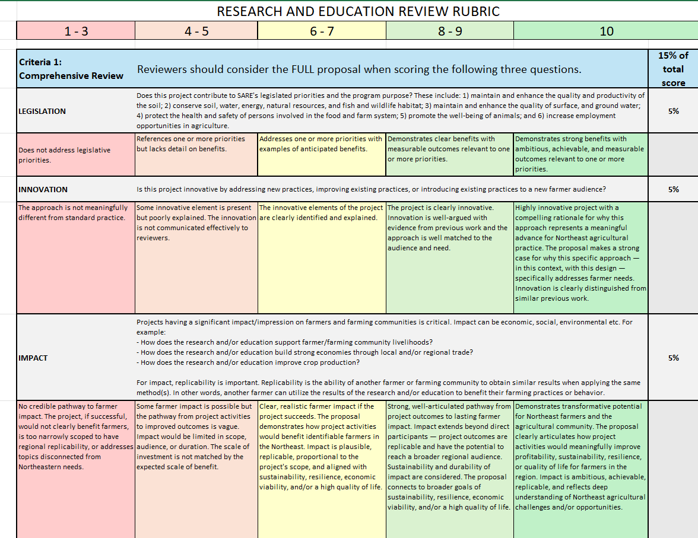

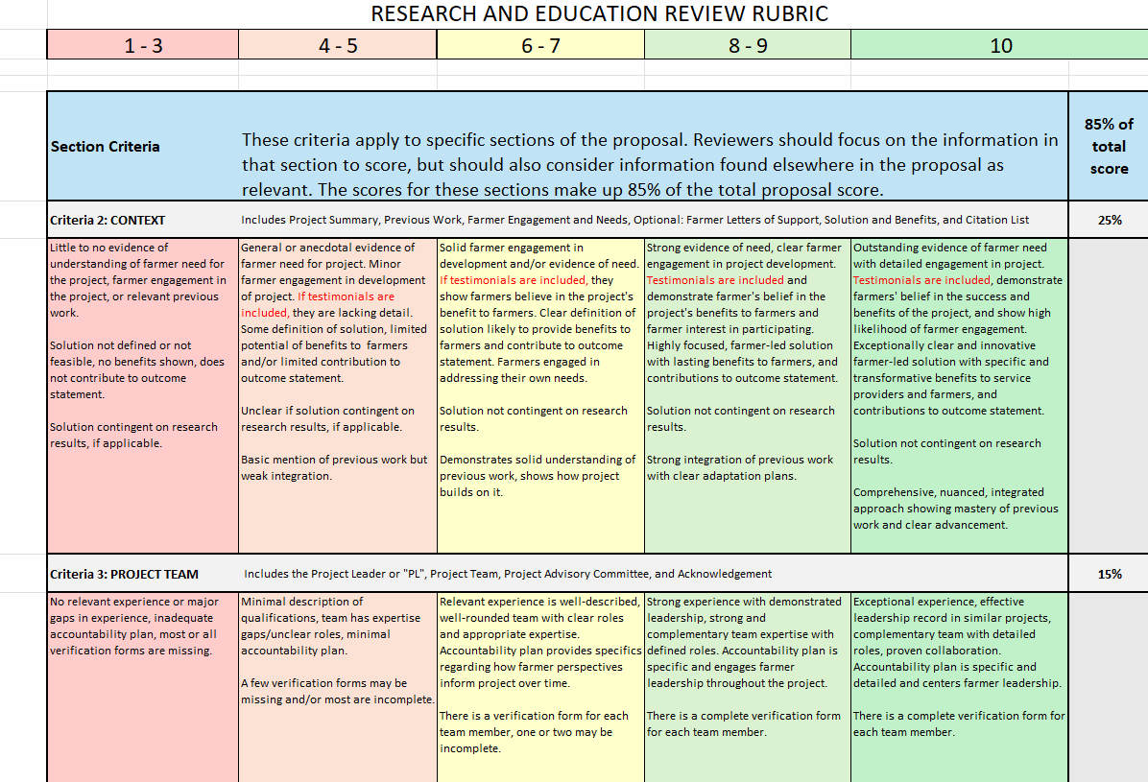
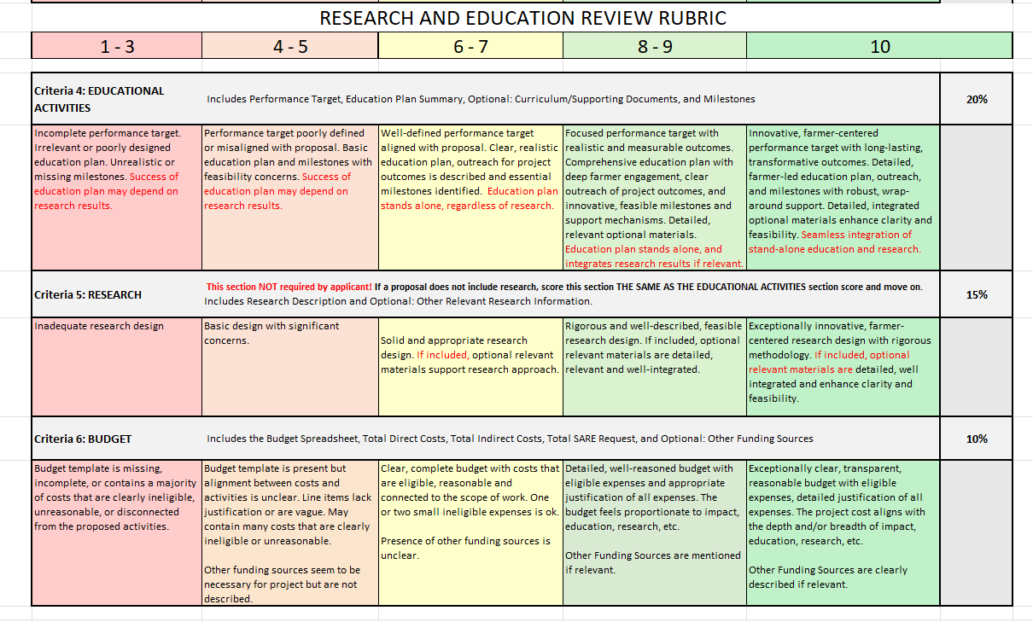

See page 2 for more guidance on ‘innovation’
Farmers must meet Northeast SARE’s Definition of a Farm at https://northeast.sare.org/farmdefinition.

