Research for Novel Approaches
Call for Proposals (CFP) Packet

Proposal Due Date: Monday, October 26, 2026, 4:00 pm ET

Proposals must be submitted online at: projects.sare.org

Questions?
Visit our website at https://northeastsare.org/NovelApproaches.
For questions about this CFP contact Kaitlyn Sirna at: northeast-na@sare.org or 440-336-0594.

All links, templates, and appendices for Large Grant Program Materials,
including registration for live Q&A sessions can be found at: northeast.sare.org/grants/get-a-grant/

About Northeast SARE
The Northeast Sustainable Agriculture Research and Education (SARE) Program offers competitive grants, in sustainable/regenerative agriculture in the Northeast region. We support agriculture in the Northeast that is regenerative so that farmers and farm employees can steward resources to ensure economic viability and a high quality of life.

SARE Legislated Priorities
By law, projects that Northeast SARE funds must contribute to SARE’s legislated priorities:
- Maintain and enhance the quality and productivity of the soil;
- Conserve soil, water, energy, natural resources, and fish and wildlife habitat;
- Maintain and enhance the quality of surface and ground water;
- Protect the health and safety of persons involved in the food and farm system;
- Promote the well-being of animals; and
- Increase employment opportunities in agriculture.

Every proposal must show how it supports one or more of these priorities. Reviewers will use this list when scoring proposals, and projects that don’t align with these priorities may not be funded.

Outcome Statement
All Northeast SARE projects must also explore one or more of the sustainable agriculture themes of the Northeast SARE outcome statement:
Northeast agricultural communities honor the holistic connection among land, water, air, and all living beings. Agriculture in the Northeast is regenerative so all farmers and farm employees can steward resources to ensure sustainability, resilience, economic viability, and a high quality of life.

Administration Priorities
Proposals submitted to this program must be in alignment with current administration priorities (i.e.
Executive Orders—https://www.federalregister.gov/presidential-documents/executive-orders; USDA Research Priorities—https://www.usda.gov/memos). We are unable to fund any proposals where the identity of a particular person and/or community is the key beneficiary. We encourage you to focus on projects that have high farmer impact and can be generally adopted by a high percentage of farmers in the Northeast. We also cannot fund projects focused on climate change but can fund projects that focus on environmental work that provide direct or indirect benefits to farmers. It is encouraged to focus on local agriculture and the significance of regenerative practices to increase production and profitability.

Farmer Impact
Projects having a significant impact/impression on farmers and farming communities is critical. Impact can be economic, social, environmental etc. For example:
- How does the project support farmer/farming community livelihoods?
- How does the project build strong economies through local and/or regional trade?
- How does the project improve crop production?

For impact, replicability is important. Replicability is the ability of another farmer or farming community to obtain similar results when applying the same method(s). In other words, another farmer can utilize the results of the research and/or education to benefit their farming practices or behavior.

Innovation
Innovation is defined as the development or adoption of new concepts or ideas and the successful exploration of new ideas. Ideation is the basis of creativity. The process of creative ideation develops new concepts; innovation applies them. Creativity can only emerge when an innovator takes the idea and puts it into practice. Innovation can also be social and develop and implement novel and effective solutions to meet social and environmental challenges. The results should improve the welfare and well-being of individual farmers and farming communities and be reproducible. Within the scope of Northeast SARE, examples can include, but are not limited to:
- The introduction of a new behavior/practice, one with which farmers are not yet familiar
- The introduction of an improved or better agricultural behavior/practice, which may not be new, but is an improvement upon what occurred before.
- The opening of a new market that has not been entered previously, whether this market has existed previously or not.
- A new source of supply of materials or goods, again irrespective of whether this source already exists or whether it has first to be created.
- Improved organizational structure and/or capacity.

Statement from USDA, NIFA
Northeast SARE is a program of the USDA, NIFA. The United States Department of Agriculture (USDA), to the extent permitted by law, will no longer make grants or otherwise fund programs or activities that improperly discriminate based on race or sex, including discrimination in the name of Diversity, Equity, and Inclusion policies. Instead, USDA will prioritize merit and efficiency. USDA recognizes programs and initiatives will have the greatest impact when these programs and initiatives put American farmers, ranchers, and foresters first by:
- solving the most pressing challenges they face;
- protecting America’s food, fuel, and fiber supply to enhance national security;
- supporting production of healthy and safe food for consumers;
- expanding and developing domestic markets;
- training the next generation of agriculturalists; and
- fueling innovation to keep American farmers at the forefront of productivity.

The National Institute of Food and Agriculture (NIFA) is committed to advancing these principles and encourages applicants to actively engage farmers, ranchers, and foresters when applying for funding opportunities to ensure relevancy and adherence to them. NIFA also encourages agricultural leaders to engage in the peer review panel process to ensure American producers are better served through research, education, and extension activities.

Projects submitted under this CFP should align with USDA Secretary’s Memorandum 1078- 020 Directive on Departmental Research and Development Priorities:
- Increasing Profitability of Farmers and Ranchers
- Expanding Markets and Creating New Uses of U.S. Agricultural Products
- Protecting the Integrity of American Agriculture from Invasive Species
- Promoting Soil Health to Regenerate Long-Term Productivity of Land
- Improving Human Health through Precision Nutrition and Food Quality

Table of Contents

This proposal packet contains several parts:
- Novel Approaches Program At a Glance
- Grant Timeline
- Grant Overview & Eligibility
- Proposal Questions and Instructions
- Appendices

PART 1: Novel Approaches Program at a Glance
Project type | This program funds applied research projects that test the feasibility and benefits of new practices or approaches in agriculture. Projects must demonstrate farmer interest and potential for impact on sustainability, resilience, and viability in the Northeast.
Geographic area | Northeast SARE grants must engage communities in the Northeast USA, which includes the following areas: Connecticut, Delaware, Maine, Massachusetts, Maryland, New Hampshire, New Jersey, New York, Pennsylvania, Rhode Island, West Virginia, Vermont, and Washington, D.C.
Grant amount and total allocation | - There is no cap on total grant requests, however, requests typically fall between $30,000 and $250,000.  - A total of $1,034,000 has been allocated to fund projects this cycle.
Success rate | Approximately 10% of submitted Novel Approaches grant proposals are funded.
Project period | - Projects may last up to three years and must conclude by 11/30/2030  - Project activities may begin after the contract start date, which is estimated to be March 1.
Estimated time to complete proposal | We estimate it will take between 35 and 45 hours to complete your proposal.
Funding | - This grant is reimbursement based; you must spend money to receive the grant funds. Please get in touch to inquire as to how small organizations have made this work for them.  - Northeast SARE grants do not require or encourage any matching funds and can be used as match funds for non-federal grant programs.
Required reporting of funded projects | - Annual progress reports are due each year of the grant.  - A final report is due within 60 days of the end of the project.

PART 2: Grant Timeline
Q&A Sessions for Inquiring Applicants
Northeast SARE staff will be hosting three Q&A sessions on the four large grants: Research & Education, Professional Development, Research for Novel Approaches, and Farming Community.
Registration is available at northeast.sare.org/largegrantqa where a FAQ page will be posted.
- Tuesday, September 1, 2026, from 4pm – 5pm ET
- Wednesday, September 23, 2026, from 10am – 11am ET
- Wednesday October 14, 2026, from 12pm – 1pm ET

Suggested date to submit accommodations requests.  To make a request, contact northeast-large-grant@sare.org. | Mon, Sept 14, 2026, 4pm ET
Full proposal submission deadline | Mon, Oct 26, 2026, 4pm ET
PLEASE NOTE THAT NO LATE SUBMISSIONS WILL BE ALLOWED, REGARDLESS OF REASON.
Final award decisions announced to applicants | Mid to Late Feb 2027

PART 3: Grant Overview & Eligibility
This part contains several sections:
- Overview
- Eligibility
- Eligible and Ineligible Expenses
- Public Domain
- Accommodation Request
- Evaluation/Scoring

Overview of Novel Approaches Grant Program
The Northeast SARE Research for Novel Approaches grant program funds ‘proof of concept’ applied research projects that are designed to confirm the benefits and/or feasibility of new practices and approaches—i.e., Novel Approaches—in agriculture.

These applied research projects must have some existing evidence from previous experiments or pilot projects (your own or others) suggesting that the practice or approach is beneficial and feasible, but further testing, data, and refinement are needed before it can be recommended for widespread adoption by farmers.

Research for Novel Approaches Grant projects require an explicit connection to the needs and interests of farmers in the Northeast. All proposals must include documented interest among farmers and service providers in utilizing or promoting the novel approach should it be proven beneficial and feasible.

This program encourages innovative solutions to challenges in farming and food systems in the Northeast USA, including but not limited to the areas of:

- Marketing and business
- Crop production
- Raising livestock
- Aquaculture
- Economic and social sustainability
- Ecological knowledge
- And more

This program does not support:
- Educational programs for the general public
- Food donation efforts
- General public awareness campaigns about agriculture and nutrition
- Community or school gardening initiatives

Eligibility
Project Leader Eligibility
The Project Leader can be anyone who works with farmers, including personnel at:
- Nonprofit organizations
- For profit businesses (such as farms) that provide agricultural consulting, veterinary services, etc.
- Farms, farmers, farm employees and farming community groups
- Communities committed to building the capacity and resilience of sustainable agriculture
- Colleges and Universities
- Cooperative Extension
- Municipalities
- State Departments of Agriculture
- Federal agencies (like NRCS)

Project leaders may only submit one proposal per grant program. Project leaders may only receive one award per program per year. If the same project is submitted to multiple grant programs, upon accepting an award, the project leader must withdraw the project from the other grant programs.

Organization Eligibility
The Project Leader must be housed at an organization that:
- Can sign and commit to a contract with Northeast SARE.
- Has enough funds to cover at least the first two months of project expenses.
  - Northeast SARE grants are reimbursement-based. Advance payments are not possible. Reimbursements can be made as frequently as monthly. The reimbursement from the first month can be used toward future months’ expenses.
- Can register in SAM.gov to get a required Unique Entity Identifier, if your project is awarded.
- Will respond promptly to communications from Northeast SARE.
- Is able to implement the project as outlined in the proposal.
- Can submit annual reports each year of the project, plus a final report within 60 days of the project end date.

Location Eligibility
Project activities must primarily take place in the Northeast region of the US, described in part 1. Applicants and host organizations may be located outside of the Northeast region.

Ineligibility
- Past SARE grant recipients with unfinished projects or unfilled reporting requirements.
- Current grant recipients who are delinquent in their project reporting.
- Identical projects being funded by another grant at Northeast SARE.
- Members of the Northeast SARE Administrative Council, SARE staff, and SARE State Coordinators

Research Requirements: IRB/IACUC
Institutional Review Board (IRB) and Institutional Animal Care and Use Committee (IACUC)
For projects containing research, Northeast SARE has specific IRB and IACUC research policies to ensure compliance with ethical research standards. You must clearly indicate your understanding of Northeast SARE's requirements by stating the status of your research regarding vertebrate animals and human subjects in your proposal.

By submitting your proposal, you acknowledge that you understand any funded project involving research with vertebrate animals or human subjects (all youth research requires a full IRB review) must have current, approved IACUC and/or IRB documentation on file with Northeast SARE before grant funds can be used for research. Northeast SARE may request this documentation, including proof of exemption, at any time. Failure to provide the required documentation may result in the suspension or forfeiture of award funds.

If required IACUC / IRB approvals are not secured, you may not proceed with those activities. Because these activities are integral to the project, non-compliance will place the entire grant in default and may lead Northeast SARE to terminate the award and close the project early.

Eligible and Ineligible Expenses
Budget categories are described in Appendix C. The appendix will provide detailed support on common budget expenses, which categories they should be classified as, and tips and directions on how to write these into your budget.

Public Domain
Proposals and reviews are kept confidential, shared only among Northeast SARE staff, Administrative Council members, and grant program reviewers. However, Northeast SARE, as a USDA NIFA program, is committed to public accessibility of results of funded projects; therefore, funded proposal text and funded project reports will be in the public domain.

Accommodation Requests
Northeast SARE is committed to accessibility for all eligible applicants. We encourage you to reach out to us regarding any challenges you experience as you plan and submit your proposal. To do so or to specifically request a disability-related accommodation, please contact Northeast SARE’s Large Grant Manager, Kaitlyn Sirna at 440-336-0594 or northeast-large-grant@sare.org.
If possible, please make your accommodation request at least three weeks prior to the proposal deadline. Northeast SARE will do our best to address requests made with less notice but may not have the resources to do so.

Proposals include required and optional attachments in Microsoft Excel and Adobe Acrobat, or PDF, formats. If you don’t have access to Microsoft Excel, you may open and edit the budget template in Google Sheets. Please contact northeast-large-grant@sare.org if you encounter any difficulties.

Evaluation/Scoring
Proposals are reviewed through a multi-step process to ensure fairness and alignment with Northeast SARE’s priorities. All reviewers receive orientation and adhere to Northeast SARE’s Conflict of Interest Policy.
- Initial Review Panels - Independent panels made up of farmers, researchers, nonprofit staff, and agricultural service providers evaluate each proposal. Single blind reviews are conducted using a detailed scoring rubric. Each question and the overall proposal are scored based on specific criteria, including alignment with program goals (ex: comprehensive review) as noted in the rubric at the end of the CFP
- Ranking – Reviewer scores and comments are reviewed by Grant Administrators for completion and creation of a ranked proposal listing.
- Oversight Panel - Top-ranked proposals from the initial review are forwarded to an oversight panel composed of USDA-NIFA representatives and the Regional Director. This group ensures that proposals meet federal administrative requirements.
- Final Funding Decisions - The oversight panel recommends a slate of proposals for funding. This slate is then submitted to the Northeast SARE Administrative Council, who ensures a fair review process and makes the final decisions on which proposals will be funded in accordance with organizational goals and priorities, and alignment with their previously approved budget and program allocations.

PART 4 Instructions and Proposal Questions
This part contains five sections, including instructions and proposal questions.
1. General Instructions to Applicants

Within the following sections, you will see the categories of questions and number of questions per category. Use this as a checklist to ensure you have completed your full application.
2. Proposal Overview
3. General Information
4. Proposal Questions
5. Host Organization

SECTION 1: General Instructions to Applicants
There are many kinds of projects that are eligible for Northeast SARE grant programs. Some project concepts may be eligible in more than one program area. Do your best to answer each question in a way that demonstrates why your project is a strong fit for the specific program you’re applying to. Appendix A includes instructions for preparing and submitting your proposal.

Tip! The national SARE project database (projects.sare.org/search-projects) includes funded projects from all four SARE regions and is searchable by state, grant type, project coordinator, and keyword. Northeast Large Grants are coded as follows: Farming Community (CNE), Research & Education (LNE), Professional Development (ENE) and Research for Novel Approaches (LNE-R).

Each question in the application includes specific guidance, which corresponds to the rubric provided. In addition, keep the following in mind as you complete your proposal:

- Northeast SARE values all ways of knowing and accepts a wide range of supporting evidence, including academic research, personal experience, community voices, cultural knowledge, and more. Examples of acceptable evidence include (but are not limited to): published literature, unpublished reports, pilot study data, survey or focus group results, community engagement records, case studies, and sources like the Census of Agriculture.
- Do not include external website links in your proposal (except in citations); reviewers will not have access to links, and they will not be considered.
- You may use any official citation style. You can learn about the different citation styles in Owl Purdue’s Style Guide Overview or learn more about research and citations here.
- Optional materials or information in the proposal are marked as such. They are not required, are not expected, and are not necessary to receive a strong score. However, these optional materials provide additional space for clarity to reviewers, which in return could impact scores. Applicants are encouraged to use optional uploads (following the instructions for allowability) in order to strengthen the reviewer’s understanding.

- Allowable file types for uploads include PDFs, images, and Excel spreadsheets. Specific questions may require a particular format. All files must be unprotected and accessible.
- You may not exceed the stated word limits, and longer responses are not viewed more favorably; Clear, concise answers are encouraged.
- Project expenses and funding requests should align with the project duration, scope of the work, and corresponding engagement and outreach.
- Northeast SARE strongly encourages that proposals request funds to pay farmers (and others who take time out of their normal work to provide a service to the project) for the time they contribute to a project at a reasonable rate. For example, Northeast SARE compensates farmers who serve on its Administrative Council and review teams at a rate of $54.40/hour.

SECTION 2: Proposal Overview
This is found on the grant management system proposal homepage and has 5 fields that are not scored by reviewers.
Title: The maximum length is 150 characters which is about 35 words or less. Please use title case.
Project Description: This description will be posted in the public Northeast SARE database if the project is funded. Limit of 300 characters.
Applicant: The name of the person who starts the proposal in the online system is automatically entered as the Applicant. The applicant can give the project leader and/or the additional editor permission to submit the application. Otherwise, the applicant must submit the application.
Project Leader: Person leading the project and responsible for successful completion of activities described in the application.
Additional Editor: The Applicant may give editing access to one additional person. The person must have an existing projects.sare.org account. Once you have added someone, a checkbox will appear allowing you to give them permission to submit the proposal on your behalf.

SECTION 3: General Information
This section has 8 questions and is not scored by reviewers.

Primary State: Select the state where the majority of work will be carried out, i.e., the primary location of the grant activities. Usually this is the home state of the project leader.
Optional: Geographic Scope: If this project will take place in more than just the primary state, list all the states where this project will take place.
Primary Commodities, Primary Practices, and Primary Benefits and Impacts: For each question (Commodities, Practices, and Benefits & Impacts), choose only the top 3–5 options that best represent your project’s primary focus areas. Do not select categories simply because they might be indirectly impacted or mentioned in your proposal. These selections are used for project classification and data aggregation, so it is important that they reflect the core focus of your work. These selections are not considered by reviewers, or a part of your proposal scoring. Definitions are in the Glossary of Appendix A.

Project Start Date
Choose a start date from the calendar pop-up. The earliest possible start date is anticipated to be March 1, 2027, but delays in the review may impact this by ± 30 days. If awarded, you will be notified at the time of award announcements the contract start date and when Northeast SARE can begin reimbursement on expenses incurred.

Project End Date
Choose an end date from the calendar pop-up. Projects must be completed by November 30, 2030.

Project Summary (550-word limit)
This is a standalone summary of the project that will be made public if the project is funded. The summary has three elements. Include subheadings to identify each element.
- Project Focus: A brief description of the farmers engaged, and the need for the project, from the perspective of farmers.
- Solution and Approach: The proposed solution and the approach to engaging farmers to address their needs.
- Comprehensive Review Criteria: Explain how your proposal contributes directly or indirectly to SARE’s legislative priorities, is innovative, and will have substantive service provider and/or farmer impact (see more detail on Comprehensive Review Criteria below).

SECTION 4: Proposal Questions
This section contains five categories of questions that align with the criteria used in the reviewer rubric. Each category’s weight and the number of questions it contains are shown below:
- Comprehensive Review – 15% of total score
  - Legislation (5%)
  - Innovation (5%)
  - Impact (5%)
- Context – 30% of total score
  - Farmer Interest and Involvement (400-word limit)
  - Previous Work (500-word limit)
  - Citation List (no word limit)
  - Optional Farmer Testimonials (Upload)
- Project Team – 15% of total score
  - Project Team (300-word limit)
  - Project Team Verification (Upload)
  - Decision – Making Process (200-word limit)
  - Accountability Plan (300-word limit)
- Research and Outreach – 30% of total score
  - Research Description (1,200-word limit)
  - Measuring Success (300-word limit)
  - Outreach and Dissemination (300-word limit)
  - Optional: Other Relevant Research Information (Upload)
- Budget – 10% of total score
  - Spreadsheet / Budget Justification and Narrative Template (Upload)
  - Other Funding Sources (200-word limit)
  - Total Direct Costs (Data entry into GMS)
  - Total Indirect Costs (Data entry into GMS)
  - Total SARE Request (Data entry into GMS)

CRITERION 1: Comprehensive Review – 15% of total score
———————————————————————————————————————
All project proposals must demonstrate alignment with Northeast SARE priorities. Reviewers will evaluate three core competencies throughout your proposal as ‘comprehensive review’. These are defined in the rubric and include:
- LEGISLATION (5%): Does this project contribute to SARE's legislated priorities? These include:
- Maintain and enhance the quality and productivity of the soil;
- Conserve soil, water, energy, natural resources, and fish and wildlife habitat;
- Maintain and enhance the quality of surface and ground water;
- Protect the health and safety of persons involved in the food and farm system;
- Promote the well-being of animals; and
- Increase employment opportunities in agriculture.
- INNOVATION (5%): Is this project innovative by addressing new practices, improving existing practices, or introducing existing practices to a new farmer audience?
- IMPACT (5%): Will the project have substantive impact on farmers’ ability to steward resources to ensure sustainability, resilience, economic viability, and a high quality of life in the Northeast?
These comprehensive review criteria guide the overall evaluation of your proposal and should be evident across multiple sections, in addition to the specific contributions described in the Project Summary.

CRITERION 2: Context – 30% of total score
———————————————————————————————————————
- Farmer Interest and Involvement (400-word limit)
Your project should be informed by and responsive to farmer need, have strong farmer interest, and authentic farmer engagement. Demonstrate evidence of this by addressing the following:
- Explain your farmer recruitment plan and strategy to engage with farmers.
- Describe how you will work with farmers throughout the project.
- Describe why your project and/or proposed approach is promising and of interest to Northeast Farmers.

- Previous Work (500-word limit)
What efforts have been made by others to solve the problem or use this opportunity? This section is the place to show reviewers how the current body of knowledge provides a foundation for your research question. Address the following:
- Describe the current knowledge and practice on this topic and how your project builds on existing efforts.
- If the practice is known but has not been applied in your community, explain how you will test what has worked elsewhere or make adaptations for your area.
- Citation List (no word limit)
Provide a list of citations referenced in your proposal using the style/format of your choosing.
- Optional: Farmer Testimonials (Upload)
Applicants are encouraged to use optional uploads (following the instructions for allowability) to strengthen the reviewer’s understanding.
You have the option to upload a maximum of 5 testimonials from farmers to document interest in the project. Project Team members cannot submit testimonials. There is no required format. Testimonials can include letters of support, emails, handwritten notes, quotes taken from surveys, etc.

Testimonials will demonstrate to reviewers that farmers:
- believe in the project’s success and benefit to farmers
- are interested in engaging with the project in some way
- Use the "Add a File" button to insert your uploads one at a time. Allowable file types for this question are PDFs and/or images. Farmer testimonials have the potential to strengthen reviewer scoring for this section.

CRITERION 3: Project Team – 15% of total score
———————————————————————————————————————
- Project Team (300-word limit)
Starting with the Project Leader, describe how the project team is structured to support successful implementation. For each team member, explain:
- The primary roles and responsibilities within the project
- The skills and experience relevant to those responsibilities
- How this role contributes to effective farmer engagement, research, outreach, or outcomes

If specific individuals are named, include name, title, and affiliation. If positions are not yet filled,
describe the role and required qualifications.
⚠️Project Team members may NOT submit farmer testimonials.
- Project Team Verification Form (upload)
The Project Leader must upload a completed version of Northeast SARE’s Project Team Verification Form for each Project Team member listed in the proposal, except for the Project Leader. The forms must be completed and signed by the Project Team members to verify their awareness of the project and commitment to fulfill their role as described in the proposal.

- Use the "Add a File" button to insert your uploads one at a time. Allowable file types for this question are PDFs and/or images.

- Decision Making Process (200-word limit)
Describe how goals are set and decisions are made within your project team to ensure a successful project. Outline the following:
- How responsibilities are allocated across research and outreach activities
- How coordination is maintained among team members.
- If applicable, explain how your team uses regular check-ins or feedback mechanisms to adjust strategies, improve project outcomes, or respond to unexpected challenges.

- Accountability Plan (300-word limit)
Each project requires a method of accountability to the project’s intended farmer audience. This section should explain how farmer perspectives will meaningfully inform project design, implementation, and learning over time. Accountability structures could be through shared leadership with outside organizations or individuals, an advisory committee, partnerships, feedback mechanisms, or take many other forms. In your narrative, describe:
- The accountability structures you will use.
- How farmers, especially those most affected, will be involved in the project.
- How feedback and lessons learned will be solicited and incorporated into program design.
- The nature of relationships between Project Team members and farmers, and how the team will work respectfully, effectively, and sensitively together.

CRITERION 4: Research and Outreach – 30% of total score
———————————————————————————————————————
Note: Research designs for this program vary widely – from replicated field trials to lab studies, on-farm demonstrations, economic feasibility analysis, and social science methods. Describe the approach that fits your question. Projects are expected to follow relevant ethical and institutional standards, including IRB and IACUC requirements where applicable – per ‘Research Requirements’.

- Research Description (1,200-word limit)
Clearly state your research question or hypothesis and demonstrate that the proposed research activities are designed to test or evaluate it rigorously. Use the following subheadings, adapting terminology as appropriate to your research approach (ex: experimental, social science, design‑based research, etc.):
- Research Question or Hypothesis - Clearly state the primary research question(s), hypothesis(es), or design/performance criteria being evaluated.
- Study or Design Approach - Describe the overall approach used to address the research question (ex: experimental design, comparative analysis, participatory research, prototype development and testing).
- Methods and Procedures - Describe the methods used to implement the study or design.
- Data Collection - Specify the data to be collected, how and when it will be collected, and steps taken to ensure data quality, reliability, or validity.
- Data Analysis and Interpretation - Describe the analytical, statistical, or evaluative methods that will be used to assess results. Explain how these methods will allow the research question or hypothesis to be evaluated and how conclusions will be drawn.

- Measuring Success (300-word limit)
Describe the key steps that will be necessary for farmers to adopt the novel approach, should the project generate the needed information to make adoption a realistic goal. Address the following:
- What are the most significant barriers to adoption (cost, access, knowledge, infrastructure, policy, values-alignment, etc.), and how does your project address or account for them?
- How will farmers obtain the design or essential components required (ex: equipment, plant/animal stock, supplies, technical knowledge) to implement the approach?
- Describe needed resources or infrastructure to implement the novel approach – i.e. if financial support is needed for adoption, where do you expect it would come from?

- Outreach and Dissemination (300-word limit)
Demonstrate how research findings will reach and benefit target farmers. Explain how results will be interpreted and presented and clearly state your dissemination methods and specific outreach publications, events, partners, or resources you will utilize.

- Optional: Other Relevant Research Information (Upload)
Applicants are encouraged to use optional uploads (following the instructions for allowability) in order to strengthen the reviewer’s understanding.
This optional section is to provide visual or supplementary materials that clarify your research approach. Examples include plot plans, sampling plans, experiment diagrams, or interview guides.
- Do not upload more than 5 total pages– reviewers will not review more than the first 5 pages.

- Use the "Add a File" button to insert your uploads one at a time. Allowable file types for this question are PDFs, images, and/or Excel spreadsheets.

CRITERION 5: Budget – 10% of total score
———————————————————————————————————————
To satisfy the budget requirements you must upload a completed Northeast SARE budget justification and narrative spreadsheet and enter the dollar amounts into the online proposal into the prompted text fields (as reflected in #3-5 below).
- Definitions of terms, eligibility, and detailed information on each budget category are provided in Appendix C.
- Download the template at: https://northeast.sare.org/FullProposalBudget.
The template file will automatically download in browser; Look for it in your downloads folder
  - Most spreadsheet software (such as Google sheets) can download or save files in .xlsx format. Please contact northeast-large-grants@sare.org if you encounter any difficulties.

- Spreadsheet / Budget Justification and Narrative Template (Upload)
Follow instructions in Tab 1 of the provided Northeast SARE Budget Justification and Narrative Template (Excel spreadsheet) to complete your proposal’s budget and justification/narrative.

If your proposal includes any sub-awards, the applicant must submit a Budget Justification and Narrative Template for each sub-awardee. For more information about what a subaward is, see Appendix C.

- Use the "Add a File" button to insert your uploads one at a time. Allowable file types for this question are Excel spreadsheets. You must use the Northeast SARE provided template.

- Other Funding Sources (200-word limit)
This section is used to support reviewer understanding of your project’s budget to assess its reasonability. For example, describing how you will obtain other resources necessary to the project’s success that may not be requested in your budget to Northeast SARE. If the budget template does not include all resources you need to complete the project, it is highly recommended to use this section to explain what else is needed and how it will be provided.
- If other resources are necessary for the success of the project, how will they be provided?
- Matching funds are not required for SARE grants. If your organization is providing facilities, resources, or significant in-kind contributions to the project, these are best described here and not in the budget justification.

- Total Direct Costs Requested
- Enter the total direct dollar amount requested (including cents) from the Budget Justification and Narrative Template (“Total Direct Costs”).
ℹ️ Direct costs are all the expenses that are specific to the project and would not be needed if the project was not funded.
- Total Indirect Costs Requested
- Enter the total indirect dollar amount requested (including cents) from the Budget Justification and Narrative Template (“Total Indirect Costs”).
ℹ️ Indirect costs are also known as “overhead” or “facilities and administration” costs. For more information about what indirect is please see Appendix C.

- Total SARE Proposal Request
- Enter the total dollar amount requested (including cents) from the Budget Justification and Narrative Template (“Total SARE Request”).
ℹ️ The total direct costs plus indirect costs requested above should add up to this number.

SECTION 4: HOST ORGANIZATION
This section has 2 required questions. This section is not scored by reviewers, and there are no review criteria.

- Authorized Official Contact Information
Provide the name and contact information of the authorized official for the organization who will serve as fiscal agent for the project.

- FDP Clearinghouse Information
Please respond to the question, “Is this organization registered in the Federal Demonstration Partnership (FDP) Expanded Clearinghouse?”

The FDP Clearinghouse is a publicly available website that provides organization profiles with information that is helpful in creating a grant contract. Being registered is NOT required. A list of participating organizations can be found at: fdpclearinghouse.org/organizations.

PART 5: Appendices
You may access the appendices referenced, using the links below:

Appendix A: Preparing and Submitting your Proposal

Appendix B: Expectations For Funded Proposals

Appendix C: Budget Guidance – Explanation of Expense Categories and Examples

Required Budget Justification and Narrative Template

All links, templates, appendices, and application materials
can be found at: northeast.sare.org/grants/get-a-grant

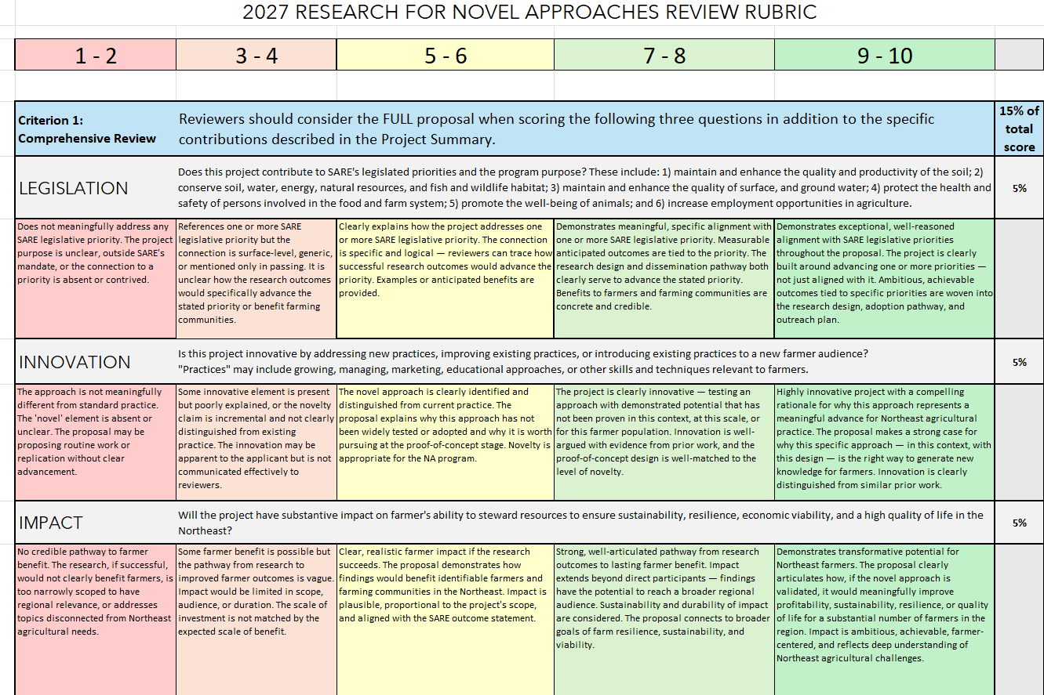

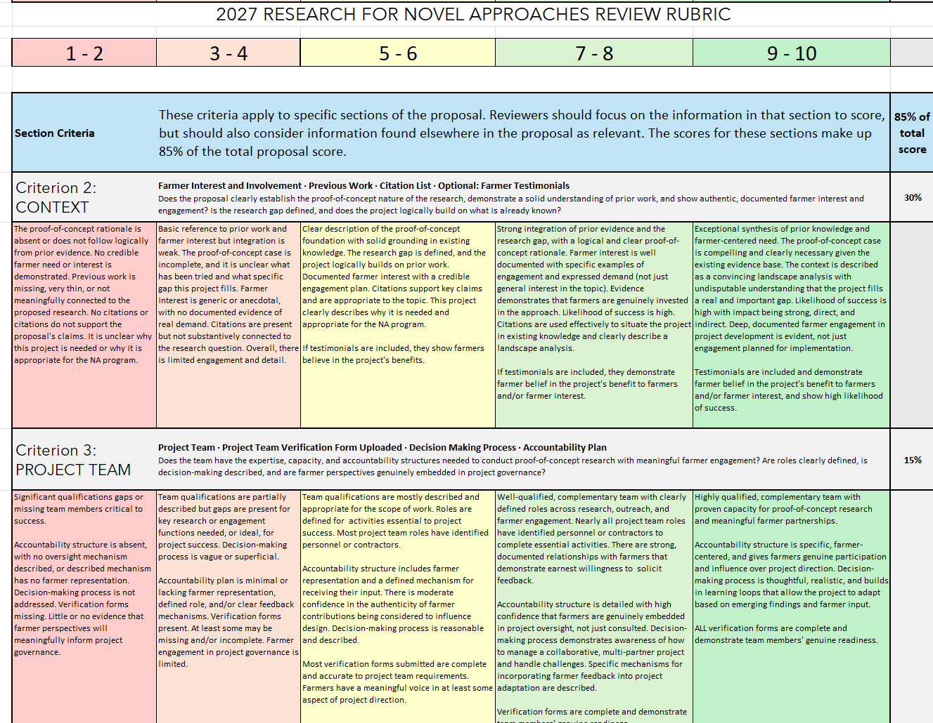
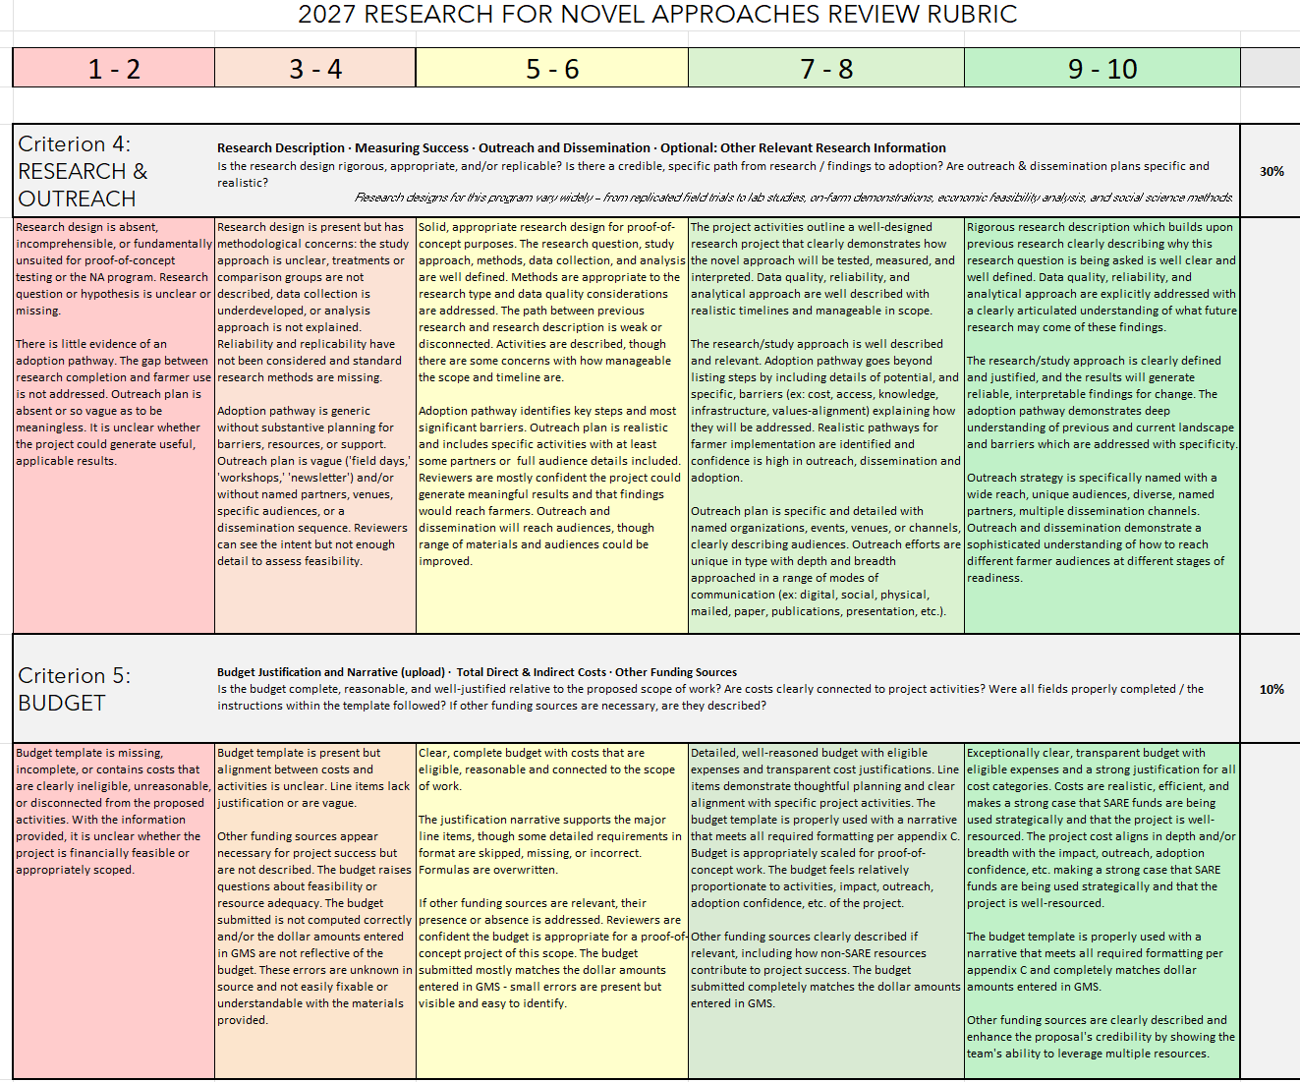

See page 2 for more guidance on ‘innovation’
Farmers must meet Northeast SARE’s Definition of a Farm at https://northeast.sare.org/farmdefinition.

